**Effects of Water Pollution on Plant Diversity**

Water pollution can have severely negative effects on biodiversity and ecosystems, particularly on plant populations. In many cases, these pollutants are introduced to the environment through everyday human activity. In this experiment, you will contaminate several water samples, as well as purify a water sample. You will then evaluate the effects of water pollution and purification on the biodiversity of wildflowers.

**POST-LAB QUESTIONS**

|  |  |
| --- | --- |
| **Table 1: Water Observations (smell, color, etc.)** | |
| **Beaker** | **Observations** |
| **1** | **No smell, clear liquid , no film, no bubbles** |
| **2** | **No smell, film in water, some bubbles, thicken liquid** |
| **3** | **Smell of vinegar, clear liquid, no film, no bubbles** |
| **4** | **Smell of detergent, film in water, bubbles, sudsy water** |
| **5** | **No smell, murky greenish brown water, no bubbles, no film** |
| **6** | **No smell, murky light brown, no bubbles, light film** |
| **7** | **Slight vinegar smell, murky light greenish brown water, no bubbles, no film** |
| **8** | **Slight detergent smell, murky light brown water, some bubbles, some suds** |

**Analysis of Results**

**1. What effects did each of the contaminants have on the water in the experiment? Use Table 1 for reference.**

Beaker two contained 10ml of vegetable oil. Vegetable oil had the following effects on the water, no smell, film in water, some bubbles, and thicken liquid. Beaker three contained 10ml of vinegar. Vinegar’s effect on the water was smell of vinegar, clear liquid, no film, and no bubbles. Beaker four had 10 mL of liquid laundry detergent. Liquid laundry detergent had affected the water with the smell of detergent, film in water, bubbles, and sudsy water.Beakers six through eight are beakers two through four filters with 10 mL of soil. Beaker six contained the filtered vegetable oil. Filtered vegetable oil had the following effects no smell, murky light brown, no bubbles, and light film. Beaker seven contained filtered vinegar. Filtered vinegar’s effects are slight vinegar smell, murky light greenish brown water, no bubbles, no film. Beaker eight had filtered liquid laundry detergent. Filtered liquid laundry detergent effects are slight detergent smell, murky light brown water, some bubbles, and some suds.

**2. What kinds of human activities could cause oil, acids, and detergents to contaminate the water supply?**

The human activities of irresponsible disposal of oil, acids and detergents can contaminate the water supply. Irresponsible disposal can take on many forms like not properly disposing of materials, illegally dumping waste, or allowing contaminates to runoff into water ways. These issues may not be apparent right away but sometime the effects can take years to surface. Oil leaks or oil spills are large manmade problems that can affect are water supplies, wild life, vegetation, and humans. Oil companies, conservations groups, and governments can clean up the initial damage but we really have yet to see the long term damages.

**3. What are the differences in color, smell, visibility, etc. between the “contaminated” water and the “treated” water?**

The contaminated water murky, mudding, has a slight film, and smells of soil. The treated water has a slight smell of bleach, clear, no film, and no bubbles. The soil has an effect on the strength of the contaminates. Some of the contaminates are absorbed by the soil and the remaining water with less contaminates goes through to the beaker.

**4. From the introduction to Lab 2, you know that there are typically five steps involved in the water treatment process. Identify the processes (e.g., coagulation) that were used in this lab and describe how they were performed.**

1. Aeration (allow increase of oxygen and gases to escape)
2. Coagulation/flocculation (The step involves adding alum to the water and stirring it in)“The alum causes compounds, such as carbonates and hydroxides, to form tiny, sticky clumps called floc that attract dirt and other small particles”. (eScience Labs. 2016).
3. Sedimentation (the clumps of dirt are separated from the water)
4. Filtration (the water is filtered through sand, charcoal, and gravel)
5. Disinfection (Chlorine or bleach is added to the water)

Step 1 was done when the water and soil combination was transferred between beakers 15 times.

Step 2 actually happened exactly how the step describes it with the adding of the alum.

Step 3 the clumps of dirt all sank to the bottom of the beaker which allowed the lighter liquid to be above in the beaker.

Step 4 I poured the liquid through the funnel which was filled with sand, charcoal, and gravel

Step 5 I added two drops of bleach to the filtered water and stirred.

**5. Develop a hypothesis regarding how using contaminated or purified water might affect plant biodiversity. Which pot do you believe will contain the greatest biodiversity (greatest number of species)? Why?**

Purified water will help biodiversity and contaminated water will hinder biodiversity. The tap water pot will contain the greatest biodiversity, next the purified water and the contaminated water will have the least.

|  |  |  |  |
| --- | --- | --- | --- |
| **Table 2: Number of Plant Species Present in the Pots** | | | |
| **Species Observed** | **Tap Water** | **Contaminated Water** | **Purified Water** |
| **Zinnia** | **Y** | **Y** | **N** |
| **Marigold** | **Y** | **Y** | **Y** |
| **Morning Glory** | **Y** | **Y** | **Y** |
| **Cosmos** | **Y** | **Y** | **Y** |
| **Ryegrass** | **Y** | **N** | **N** |
| **Total Number of Species in Pot:** | **5** | **4** | **3** |

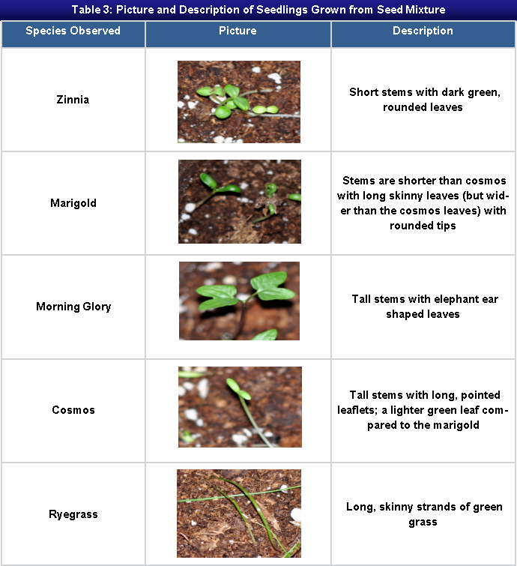

1. **Based on the results of your experiment, would you reject or accept the hypothesis that you produced in question 5? Explain how you determined this.**

I accept my original hypothesis from question five. Tap Water had the greatest diversity and growth amount in this test. The Purified Water had the second greatest diversity and growth amount in the test. Finally, the Contaminated Water had the least diversity and growth amount in the test.

1. **Alum contains aluminum. Research the effects of aluminum on plants by finding a scholarly source online. Does your research provide any insight into your results? Discuss your findings as they relate to the results of your experiment.**

I did research and I found a scholarly source on how aluminum affects plants. Yes, the research supports my hypothesis and my findings. Aluminum hampers the growing process of plants. “Aluminum being the third most abundant metal in the earth's crust poses a serious threat to crop productivity in acid soils, which comprise almost half of the arable land”. (Panda & Matsumoto, 2007).

1. **Imagine that each pot was a sample you found in a group of wildflowers. Based on the diversity of flowers in each pot, would you consider the ecosystem to be healthy? Why or why not?**

I would consider the Tap Water ecosystem healthy. The Purified Water ecosystem and the Contaminated Water ecosystem are less healthy. This is proven from the results of growth from each ecosystem.

1. **How does biodiversity contribute to the overall health of an ecosystem? Provide specific examples and utilize at least one scholarly resource to back your answer.**

There is a reciprocal effect between the amount of biodiversity and the health of the ecosystem. Both are necessary to ensure the health of the other. The example I found is about the biodiversity of grasshoppers contributing to health of grasslands in China. “Grasshopper biodiversity is the result of the evolution of grassland ecosystems; however, it also impacts on the structure and the function of those ecosystems” (Zhong-Wei, Hong-Chang & Ya-Ling, 2006).

1. **Rank the following three scenarios in terms of having the most to least biodiversity and provide your rationale for these rankings.**

* **A vacant lot behind a car repair facility.**
* **A designated national wilderness area.**
* **A grassy strip along the highway.**

1. A designated national wilderness area.
2. A grassy strip along the highway.
3. A vacant lot behind a car repair facility.

**References**

eScience Labs. (2016). Environmental science student manual. Sheridan, CO: eScience Labs

Panda, S. K., & Matsumoto, H. (2007). Molecular Physiology of Aluminum Toxicity and Tolerance in Plants. Botanical Review, 73(4), 326.

Turk, J., & Bensel, T. (2014). [*Contemporary environmental issues*](http://outboundsso.next.ecollege.com/default/launch.ed?ssoType=CDMS&redirectUrl=https://content.ashford.edu/ssologin?bookcode=AUSCI207.14.2) (2nd ed.). San Diego, CA: Bridgepoint Education, Inc.

Zhong-Wei, G., Hong-Chang, L., & Ya-Ling, G. (2006). Grasshopper (Orthoptera: Acrididae) biodiversity and grassland ecosystems. *Insect Science*, *13*(3), 221-227. doi:10.1111/j.1744-7917.2006.00086

